Department of Computer Science & Engineering

Final Year B. Tech. (CSE) – I: 2022-23 5CS462: PE5 - Data Mining Lab

Assignment No. 1

PRN: 2020BTECS00205

NAME: Monika .V. Chitrakathi

BATCH: B8

Design the data analysis tool (GUI) to perform the following task:

1. Data upload ( std. format like .csv, excel etc. ) and view
   * Data Upload

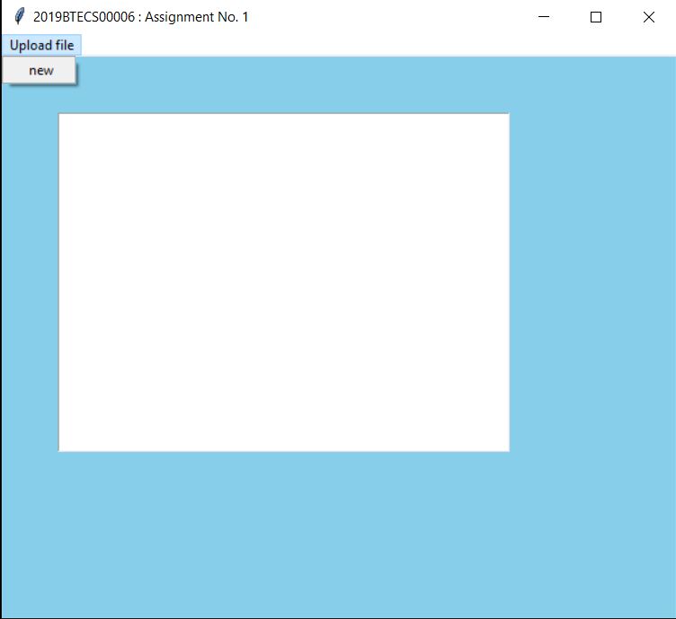

* + View

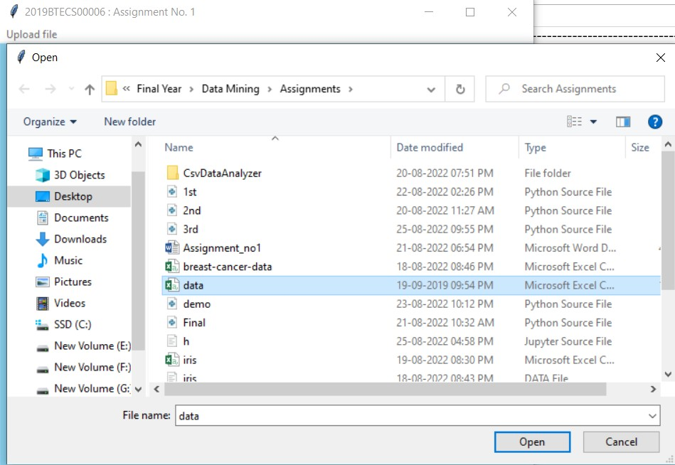

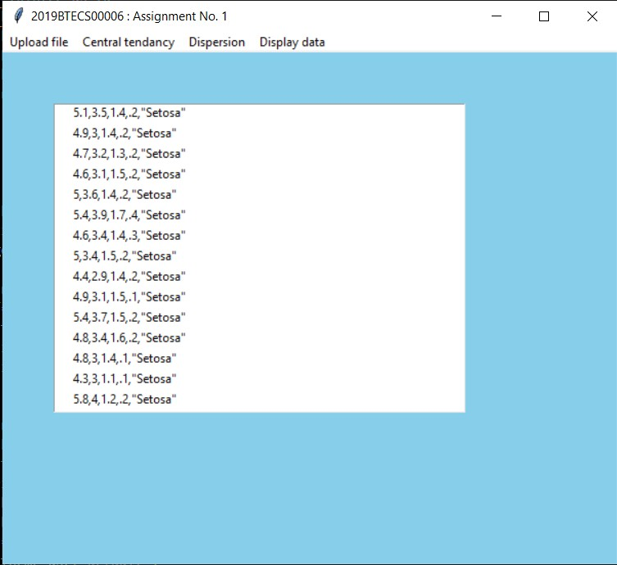

1. Calculate and show the measures of central tendency for uploaded data

: mean , median , mode , midrange , variance and standard deviation

* + Mean

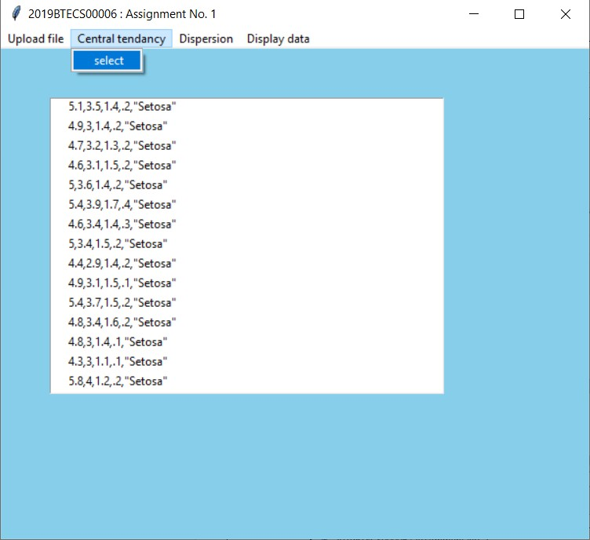

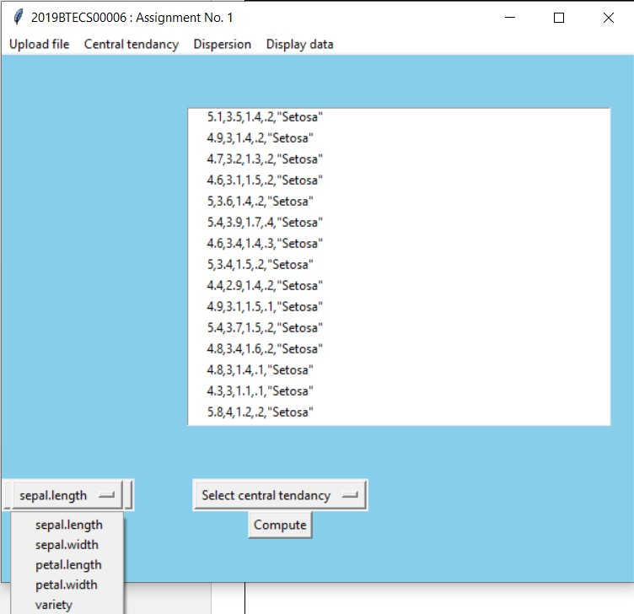

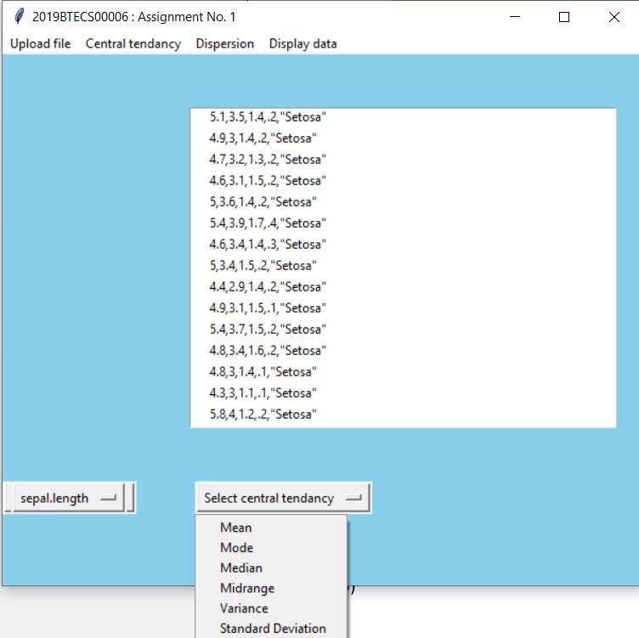

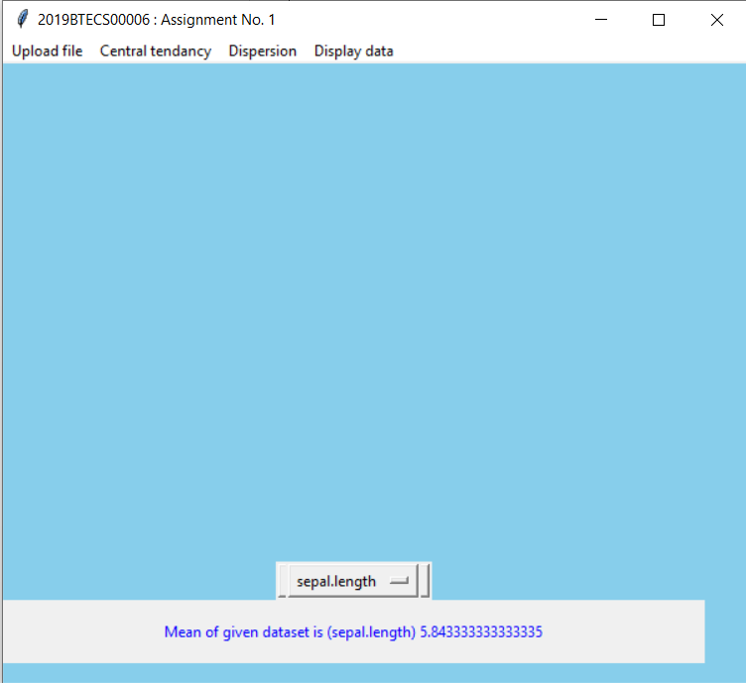

* + Mode:

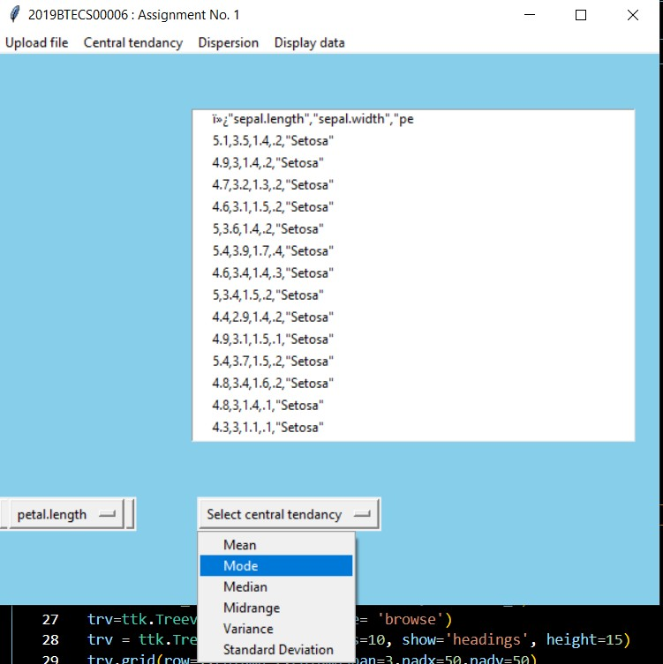

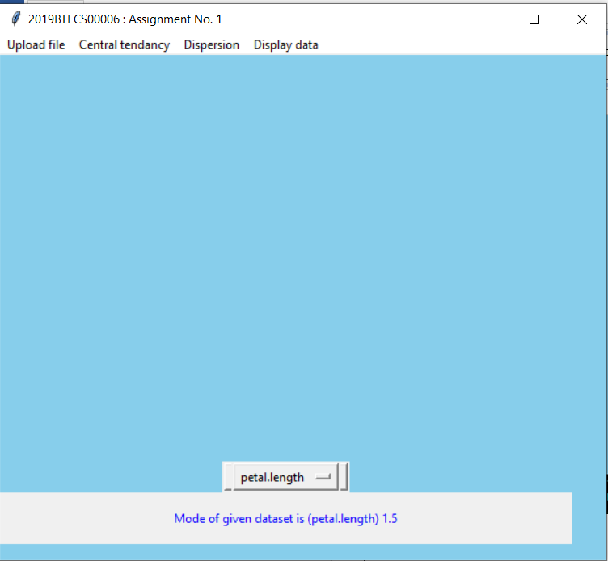

* + - Mode

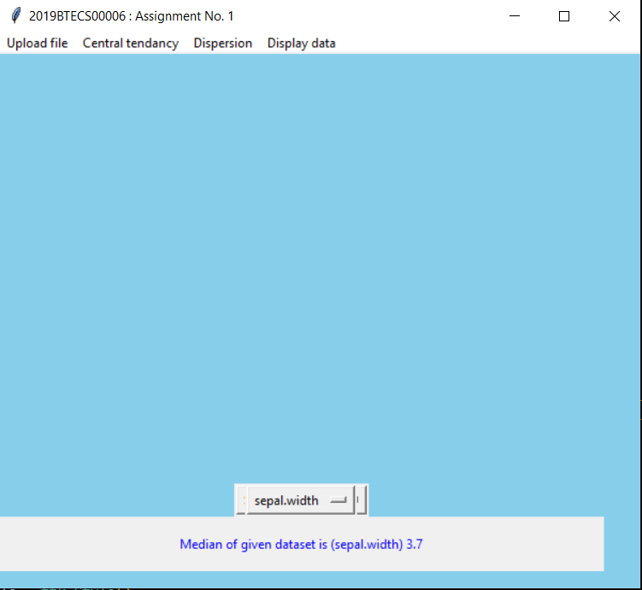

* + Midrange

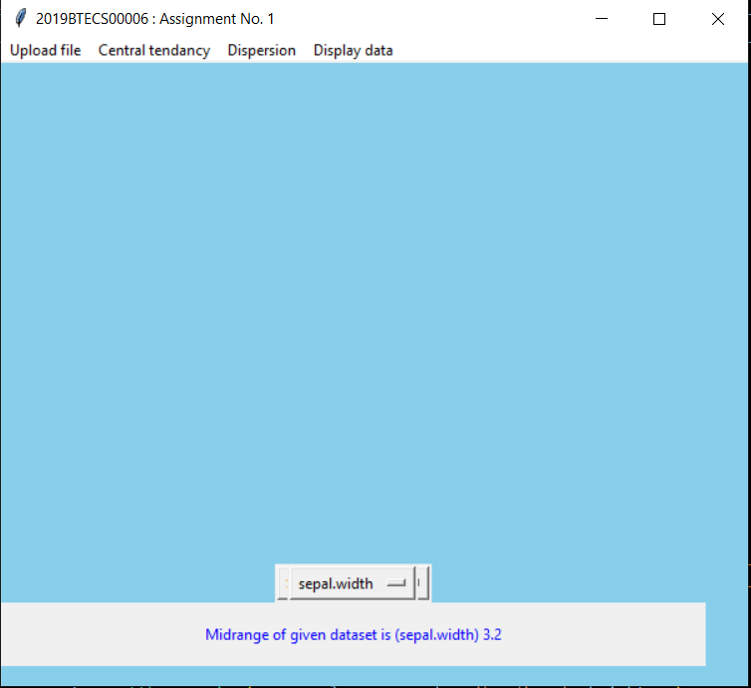

* + Variance

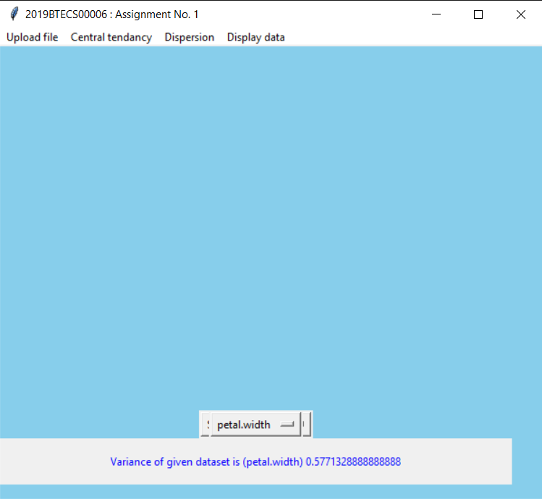

* + Standard deviation

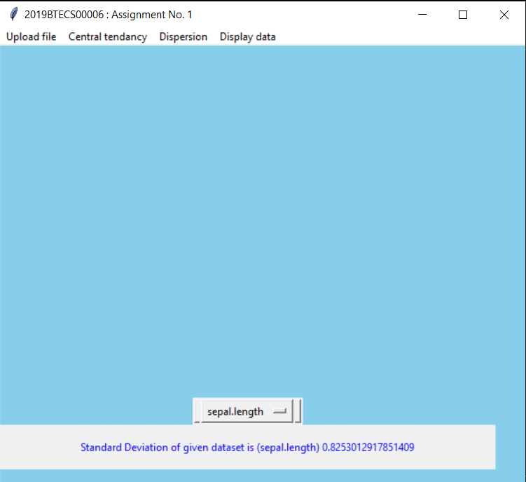

1. Calculate and show the dispersion of data : range , quartiles , interquartile range , five-number summary
   * Range

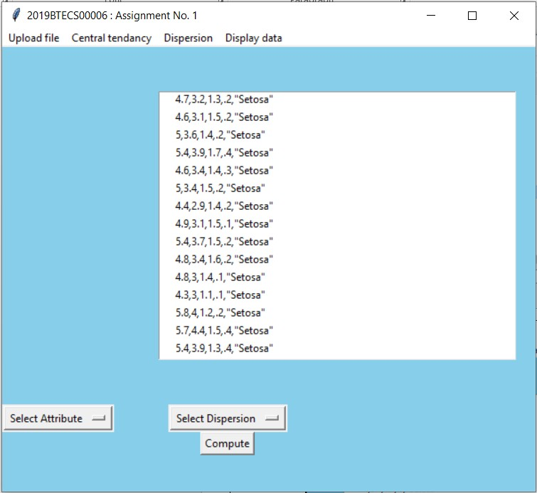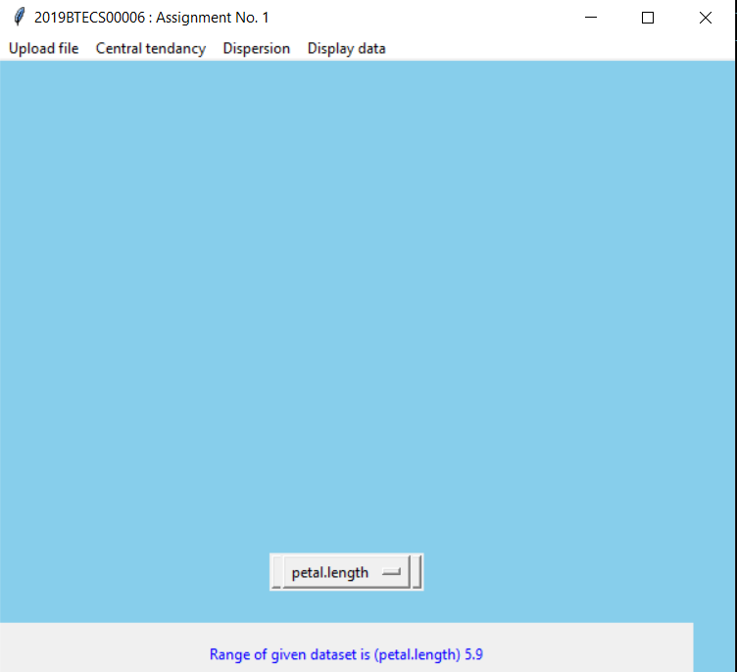

* + Lower Quartile

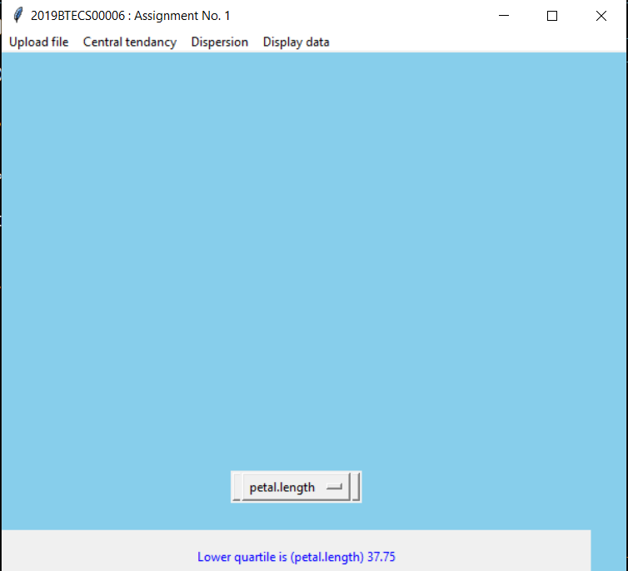

* + Interquartile Range

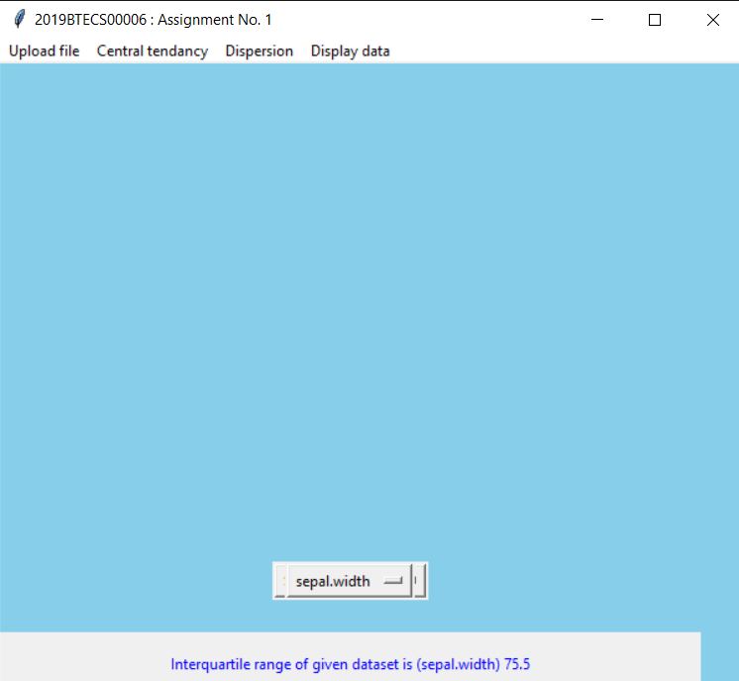

* + Five-Number Summary

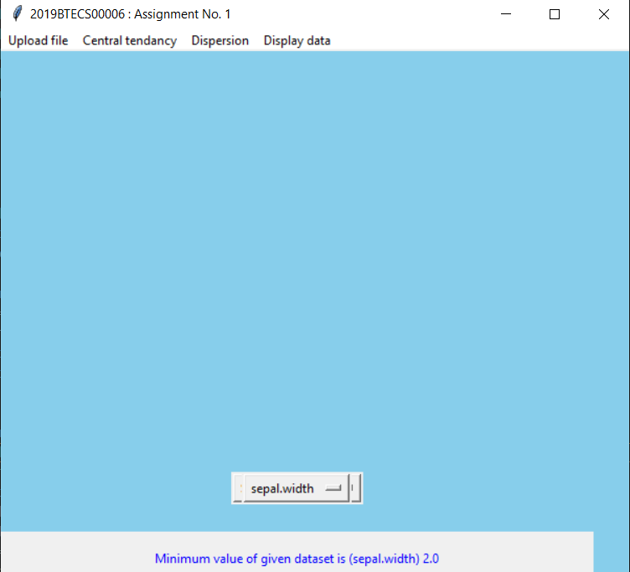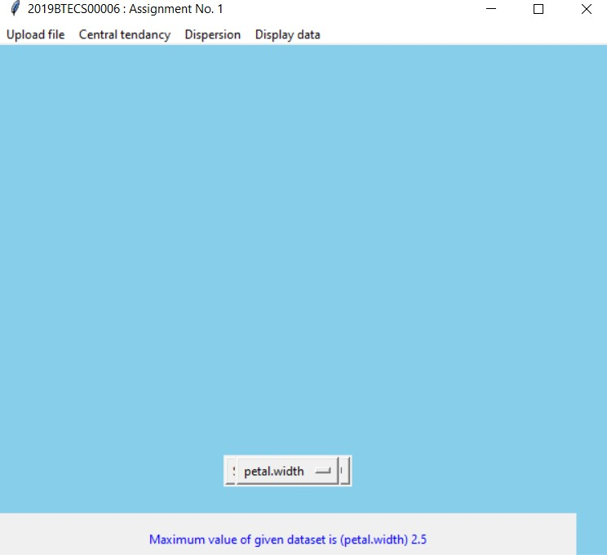

1. Graphical display of above calculated statistical description of data (provide the facility - UI form to choose different attributes from uploaded data set) : a. Quantile plot b. Quantile-quantile (q-q) plot c.

Histogram d. Scatter plot e. Boxplot

1. Quantile Plot:
2. Quantile-Quantile Plot:
3. Histogram:

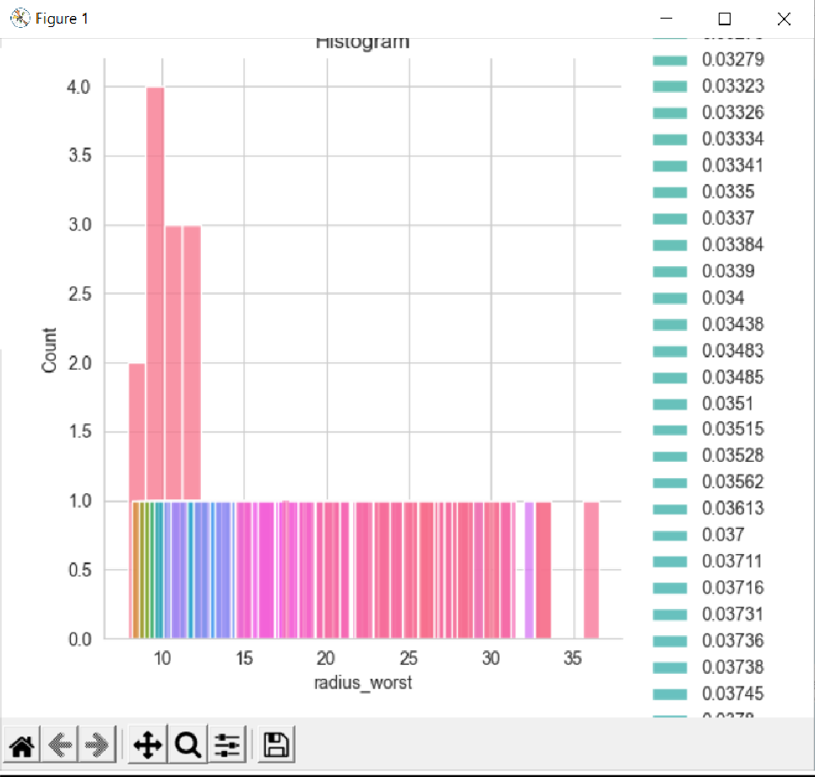

1. Scatter Plot:

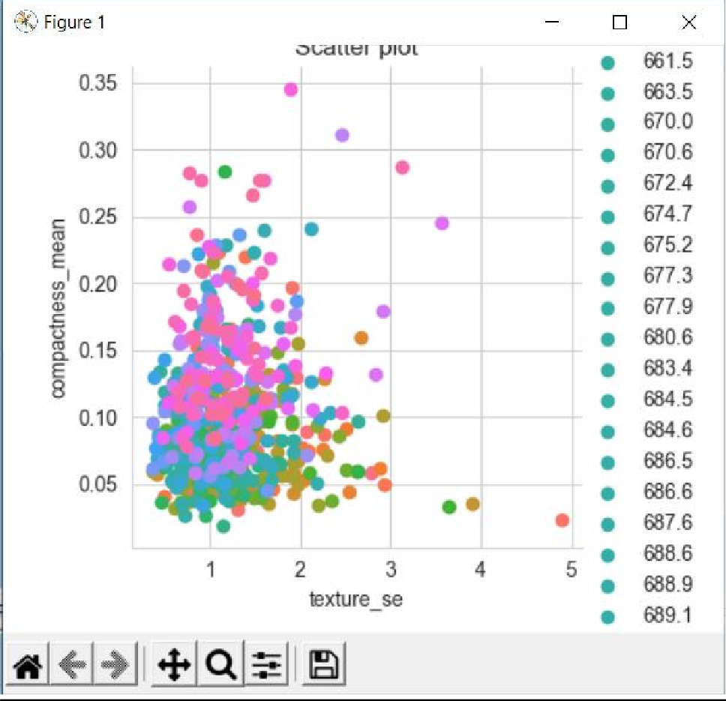

1. Boxplot:

